Dataset: Pokémon with Stats
Download: Kaggle — Pokémon with Stats

1. Introduction | Giriş
You are a Pokémon data analyst! Your mission is to explore Pokémon characteristics, compare their battle statistics, identify interesting patterns, and communicate your findings through visualizations.

2. Dataset information | Dataset haqqında
The dataset contains information about Pokémon, including their names, types, generations, and battle statistics.
Column | Description
Name | Pokémon's name / Pokémon-un adı
Type 1 | Primary type / Əsas növ
Type 2 | Secondary type, if available / Əlavə növ
Total | Sum of the six main battle stats / Altı əsas göstəricinin cəmi
HP | Health points / Sağlamlıq xalı
Attack | Physical attack / Fiziki hücum
Defense | Physical defense / Fiziki müdafiə
Sp. Atk | Special attack / Xüsusi hücum
Sp. Def | Special defense / Xüsusi müdafiə
Speed | Speed / Sürət
Generation | Pokémon generation / Pokémon nəsli
Legendary | Whether it is legendary / Əfsanəvi olub-olmaması

Part 1 — Getting started | İlkin araşdırma
Task 1.1 — Load the dataset | Dataset-i yüklə
- Import Pandas, NumPy, Matplotlib, and Seaborn.
- Load the CSV file into a DataFrame named df.
- Display the first 10 rows.
- Display the last 5 rows.
- Find the number of rows and columns.
- Display all column names.
Task 1.2 — Understand the data | Məlumatları tanı
- Display the data types of all columns.
- Check the number of non-null values in each column.
- Generate descriptive statistics for numerical columns.
- Count the unique Pokémon names.
- Find the number of unique primary types.
- List all unique values in Generation.

Part 2 — Data cleaning | Məlumatların təmizlənməsi
Task 2.1 — Missing values and duplicates | Boş dəyərlər və təkrarlar
- Count missing values in every column.
- Calculate the percentage of missing values in each column.
- Check whether duplicate rows exist.
- If duplicates exist, remove them and compare the DataFrame's shape before and after cleaning.
- Investigate missing values in Type 2.
- Decide how missing Type 2 values should be interpreted. Do not automatically assume that every missing value is an error.
Task 2.2 — Validate the data | Məlumatları yoxla
- Check whether the six main battle statistics contain negative values.
- Check whether Generation contains unexpected values.
- Check whether Name contains missing values.
- Confirm that the numerical columns have appropriate data types.

Part 3 — Filtering and sorting | Filtrləmə və sıralama
Use Boolean conditions, .loc[], and sorting methods to answer the following questions.
- Find all Pokémon whose Attack is greater than 100.
- Find Pokémon whose Speed is greater than 100 and Defense is greater than 80.
- Select all Pokémon whose primary type is Water.
- Find all legendary Pokémon.
- Find all Pokémon from Generation 1.
- Display the 10 Pokémon with the highest Total.
- Display the 10 Pokémon with the lowest Speed.
- Find Pokémon whose primary type is Fire and whose Attack is greater than 90.
- Find Pokémon that have no secondary type.
- Find Pokémon that are legendary and have Speed greater than 90.

Part 4 — Feature engineering | Yeni sütunların yaradılması
Create new columns to support deeper analysis.
Task 4.1 — Calculate new features | Yeni göstəricilər yarat
- Create a column named Average_Stat containing the average of HP, Attack, Defense, Sp. Atk, Sp. Def, and Speed.
- Create a column named Offensive_Power by adding Attack and Sp. Atk.
- Create a column named Defensive_Power by adding Defense and Sp. Def.
- Create a column named Strength_Category using the following rules based on Total:
Condition | Category
Total less than 300 | Weak
Total from 300 to 499 | Moderate
Total 500 or higher | Strong
5. Create a column named Has_Secondary_Type indicating whether a Pokémon has a secondary type.
Task 4.2 — Analyze the new features | Yeni göstəriciləri təhlil et
- Count Pokémon in each strength category.
- Find the Pokémon with the highest Offensive_Power.
- Find the Pokémon with the highest Defensive_Power.
- Compare the average Average_Stat for legendary and non-legendary Pokémon.

Part 5 — GroupBy and aggregation | Qruplaşdırma və aqreqasiya
Use groupby(), aggregation functions, and sorting.
- Count the Pokémon belonging to each primary type.
- Calculate the average Attack for each primary type.
- Calculate the average Defense for each primary type.
- Find the average Speed for each generation.
- Count legendary and non-legendary Pokémon.
- Calculate the average Total for legendary and non-legendary Pokémon.
- Find the five primary types with the highest average Total.
- Calculate the minimum, maximum, and mean HP for each generation.
- Compare the number of Pokémon with and without a secondary type.
- Group by Type 1 and Legendary and calculate the average Attack.

Part 6 — Pivot tables | Pivot cədvəlləri
Use pd.pivot_table() to explore multiple dimensions at once.
- Create a pivot table showing the average Total for each combination of Type 1 and Legendary.
- Create a pivot table showing the average Attack for each Generation and Type 1.
- Create a pivot table counting Pokémon by Generation and Legendary.
- Create a pivot table comparing the average HP, Attack, and Defense across generations.
- Identify which primary types have no legendary Pokémon in the dataset.

Part 7 — Data visualization | Məlumatların vizuallaşdırılması
Use Matplotlib and Seaborn. Every chart must have an informative title, labelled axes, and readable labels.
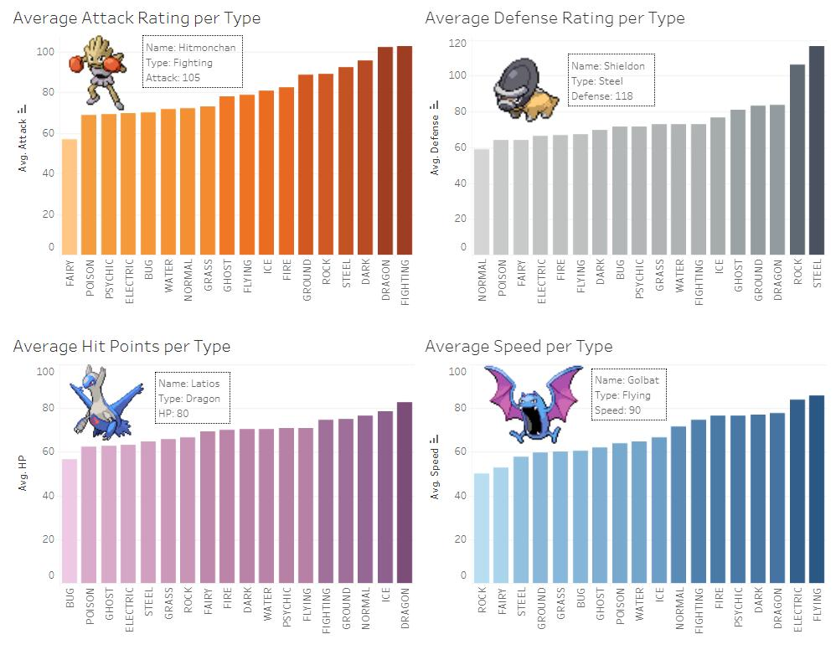
Chart 1 — Pokémon by type
Create a bar chart showing the number of Pokémon in each primary type. Sort the categories by count.
Əsas növlər üzrə Pokémon sayını göstərən sıralanmış sütun qrafiki yarat.
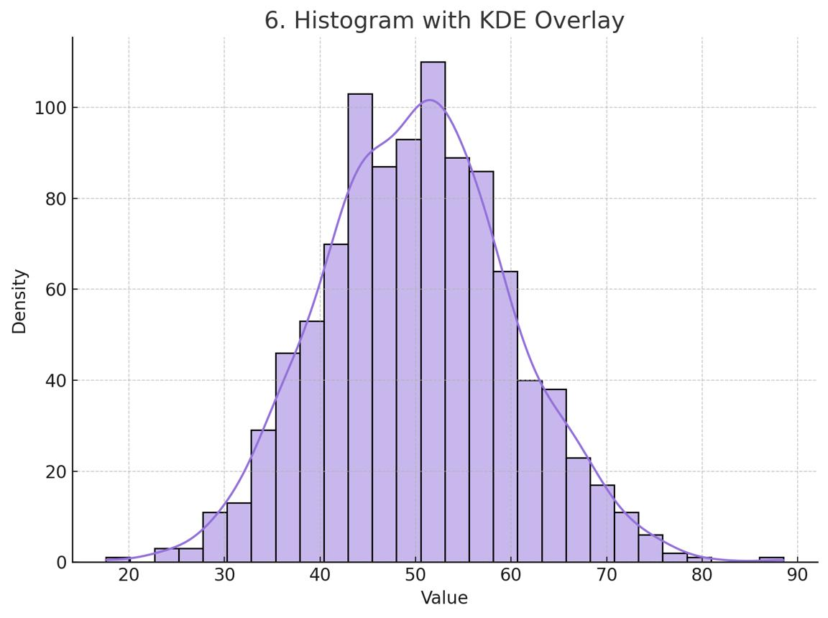
Chart 2 — Distribution of Total
Create a histogram of Total. Describe the distribution and identify where most Pokémon fall.
Total göstəricisinin histogramını qur və paylanmanı izah et.
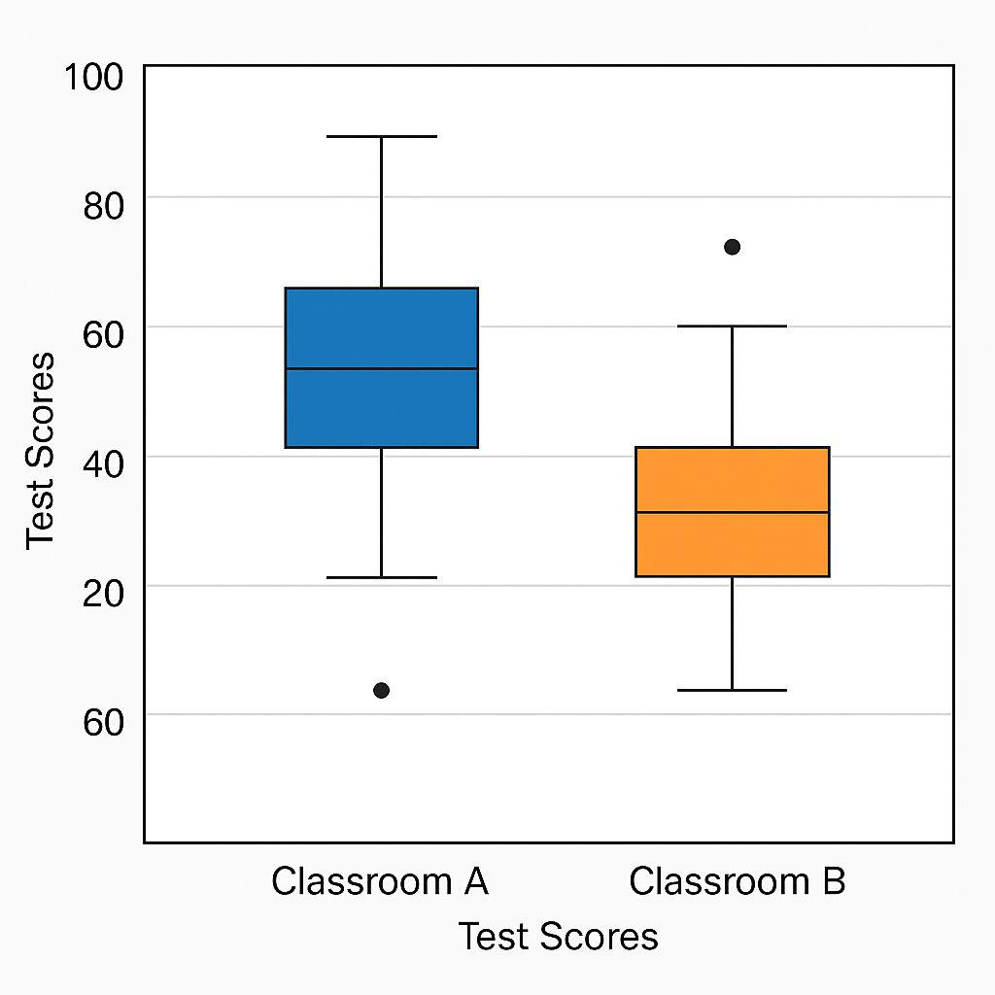
Chart 3 — Legendary vs non-legendary
Use a box plot to compare Total between legendary and non-legendary Pokémon.
Əfsanəvi və digər Pokémon-ların Total göstəricilərini box plot vasitəsilə müqayisə et.
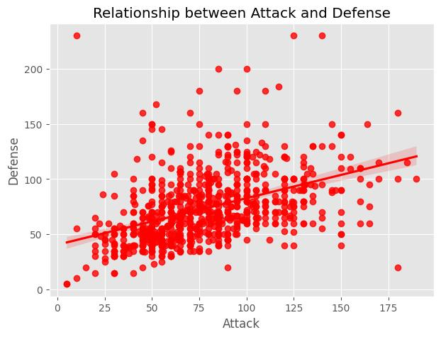
Chart 4 — Attack vs Defense
Create a scatter plot with Attack on the x-axis and Defense on the y-axis. Use different colors for legendary and non-legendary Pokémon.
Attack və Defense arasındakı əlaqəni əfsanəvi statusa görə rənglənmiş scatter plot ilə göstər.
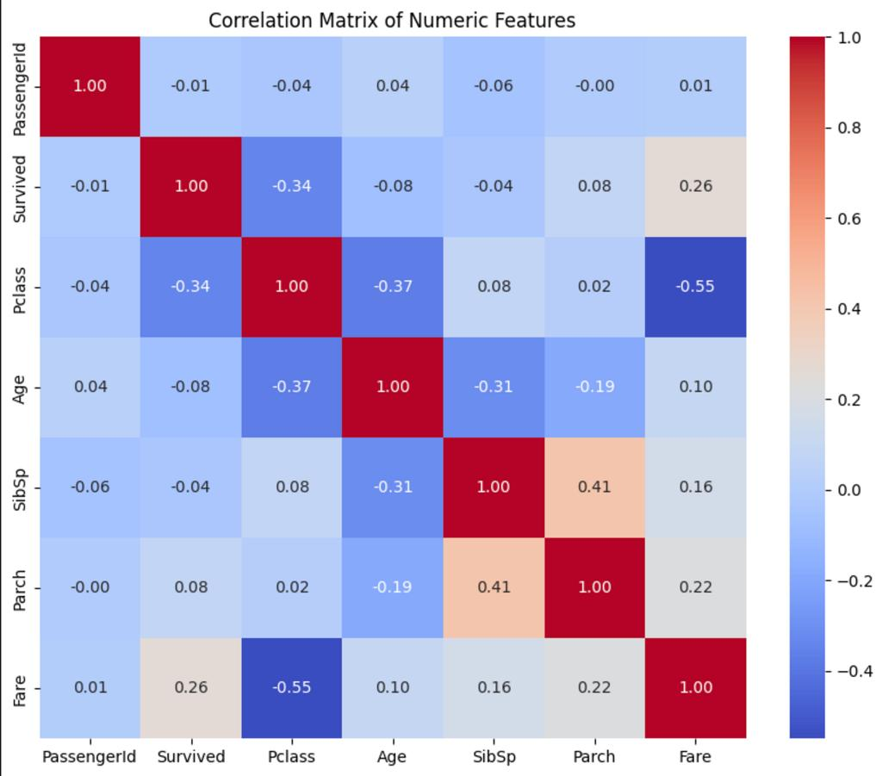
Chart 5 — Correlation heatmap
Create a correlation heatmap for the six main battle stats and Total.
Altı əsas döyüş göstəricisi və Total arasındakı korrelyasiyanı heatmap ilə göstər.

